# Table of Contents

Title Page i

Declaration of the Student ii

Course Completion Certificate iii

Acknowledgement iv

Executive Summary v

List of Figures vi

1. **INTRODUCTION**
   1. What is GHG Protocol? 2
   2. Training Specifications 3
   3. Hardware Specification 4
   4. Software Specification 4
2. **LITERATURE SURVEY**
   1. Project: Graph Protocol Taxonomy 5
   2. Proposed System 7
   3. Feasibility Study 9
      1. Technical Feasibility 9
      2. Economic Feasibility 9
3. **SYSTEM DESIGN**
   1. Requirement Specification 10
   2. Steps to Configure 13
4. **RESULTS** 19
5. **CONCLUSION** 21
6. **REFERENCES** 22

**CHAPTER-1**

## 1. INTRODUCTION

## 1.1 What is GHG Protocol?

## The GHG Protocol, or Greenhouse Gas Protocol, is a widely used international accounting tool for measuring and managing greenhouse gas emissions. It was developed by the World Resources Institute (WRI) and the World Business Council for Sustainable Development (WBCSD) in 1998 and has since become the most widely used GHG accounting standard in the world. The GHG Protocol is used by businesses, governments, and other organizations to track their greenhouse gas emissions, set reduction targets, and report their progress. It has helped to standardize GHG accounting and reporting, making it easier to compare emissions across different organizations and sectors.

The current state of GHG emissions reporting lacks a standardized and universally accepted framework, resulting in several challenges:

1. **Inconsistency:** Different organizations and industries calculate and report GHG emissions using diverse methodologies, making it difficult to accurately compare and aggregate data. This inconsistency hinders efforts to monitor progress toward emission reduction objectives.
2. **Complexity:** The GHG Protocol includes multiple scopes (Scope 1, Scope 2, and Scope 3 emissions) and sector-specific guidelines, which increase the complexity of accounting for emissions. It is difficult for organizations to navigate these complexities, which hinders accurate reporting.
3. **Lack Of Sectoral Specificity:** While the GHG Protocol provides general guidelines, numerous industries require sector-specific emission factors and methodologies. In the absence of sector-specific taxonomies, industry-specific emissions reporting is hampered.
4. **Evolving Reporting Requirements:** As international regulations and stakeholder expectations change, organizations confront the challenge of keeping up with ever-evolving reporting requirements. This dynamic environment requires a taxonomy capable of adapting to new standards.

# 1.2 Training Specification

Training a comprehensive GHG Protocol Taxonomy requires a structured and collaborative approach involving experts in climate science, emissions accounting, data analytics, and industry-specific knowledge. Below are the training specifications for developing the taxonomy:

1. **Interdisciplinary Team:** Assemble a diverse team of experts, including climate scientists, environmental engineers, data scientists, economists, and industry specialists. This team should have a deep understanding of greenhouse gas emissions, emissions accounting, and the unique challenges faced by various sectors.
2. **Data Collection:** Gather extensive data on greenhouse gas emissions from various industries and organizations. This data should include emissions factors, methodologies, and historical emissions data.
3. **Review Existing Standards:** Conduct a thorough review of existing GHG emissions reporting standards, including the GHG Protocol, ISO 14064, and industry-specific guidelines. Identify gaps, inconsistencies, and areas for improvement.
4. **Stakeholder Engagement:** Engage with stakeholders, including industry associations, government agencies, environmental organizations, and businesses, to gather input and ensure that the taxonomy addresses their needs and concerns.

# 1.3 HARDWARE SPECIFICATION

|  |  |
| --- | --- |
| Processor | : Intel Core i5 processor or above |
| RAM | : Minimum 4 GB or more. |
| Hard Disk | : Minimum 20 GB of space |

Storage Device : SSD of 128 GB

Input Device : Keyboard

# 1.4 SOFTWARE REQUIREMENTS

Operating system : Window

IDE : CMD, VS Code, Neo4J Admin Tool

Language : Python, Cypher

Framework : Neo4J, APOC, React

Tech stacks : Graph Databases, AutoML, Airflow, Perfect, Mage-ai, AWS

**CHAPTER -2**

# 2. LITERATURE SURVEY

**2.1** **Project:** **GHG-Protocol Taxonomy** (Basic Structure)

Basic taxonomy for the GHG Protocol, organized from the highest level to the lowest:

1. GHG Protocol Standard

* Corporate Accounting and Reporting Standard
* Product Accounting and Reporting Standard

1. GHG Protocol Scope

* Scope 1: Direct GHG emissions
* Scope 2: Indirect GHG emissions from purchased electricity, heat, and steam
* Scope 3: Other indirect GHG emissions, such as from transportation, waste disposal, and supply chain activities

1. GHG Protocol Category

* Category 1: Energy
* Category 2: Industrial Processes
* Category 3: Agriculture, Forestry and Other Land Use (AFOLU)
* Category 4: Waste
* Category 5: Other

1. GHG Protocol Emissions Source

* Emissions from fossil fuel combustion
* Emissions from industrial processes
* Emissions from agriculture and forestry activities
* Emissions from waste disposal
* Emissions from transportation and distribution
* Emissions from upstream and downstream activities in the supply chain

1. GHG Protocol Gas

* Carbon dioxide (CO2)
* Methane (CH4)
* Nitrous oxide (N2O)
* Hydrofluorocarbons (HFCs)
* Perfluorocarbons (PFCs)
* Sulphur hexafluoride (SF6)
* Other greenhouse gases

This taxonomy provides a framework for organizing and categorizing different aspects of the GHG Protocol, including the different standards, scopes, categories, emissions sources, and greenhouse gases. It can be useful for organizations looking to implement the GHG Protocol and track their greenhouse gas emissions.

**Applications GHG-Protocol Taxonomy**

This taxonomy can be used in several ways:

1. **GHG Protocol implementation** - Organizations can use this taxonomy as a guide for implementing the GHG Protocol and measuring their greenhouse gas emissions. By categorizing emissions sources and greenhouse gases, they can better understand their carbon footprint and identify opportunities for reducing emissions.
2. **Reporting and disclosure** - Companies can use this taxonomy to report their greenhouse gas emissions to stakeholders, such as investors, customers, and regulatory agencies. By using a standardized taxonomy, they can ensure that their emissions reporting is consistent and transparent.
3. **Comparability** - This taxonomy can be used to compare greenhouse gas emissions across different organizations, industries, and regions. By using a common language and framework, it is easier to compare emissions data and identify best practices for reducing emissions.
4. Research - Scientists and researchers can use this taxonomy to study different aspects of greenhouse gas emissions, such as the impacts of different emissions sources and greenhouse gases on climate change.

**2.2 PROPOSED SYSTEM**

**Workflow**

* Export data from Solidatus (implemented taxonomy tool) in json format
* parse through json file and get the data into dataframe
* Upload converted data into Neo4j to create a graph database using data importer
* Use graph visualizers compatible with neo4j
* Further use it accordingly to implement it on frontend.

**Requirements**

To visualize the GHG Protocol taxonomy, along with the reasons for using various tools and databases. Here's a step-by-step guide:

1. **Data Requirements:** To construct the GHG Protocol taxonomy visualization, you will need access to emissions data and emissions factor data. Emissions data can be obtained from your organization's internal sources, such as energy and fuel consumption data, or from external sources, such as government agencies and industry associations. Emissions factor data can also be obtained from these sources.
2. **Data Cleaning:** Once you have obtained the emissions and emissions factor data, you will need to clean and process the data to ensure it is accurate and consistent. This may involve removing duplicates, correcting errors, and standardizing units of measurement.
3. **Taxonomy Mapping:** The next step is to map the emissions data to the GHG Protocol taxonomy. This involves categorizing emissions data into the appropriate emissions sources and categories within the taxonomy.
4. **Data Visualization:** Once the emissions data has been mapped to the GHG Protocol taxonomy, you can use a graph database to visualize the taxonomy. A graph database is a database that uses graph structures to represent and store data. In the case of the GHG Protocol taxonomy, a graph database can be used to represent the taxonomy as a network of nodes (representing emissions sources and categories) and edges (representing relationships between sources and categories).
5. **Graph Database:** Neo4j is a popular graph database that can be used to visualize the GHG Protocol taxonomy. Neo4j provides a flexible and scalable platform for storing and querying graph data. It also includes a variety of visualization tools and plugins for creating custom visualizations of the data.
6. **Graph Visualization Tool:** There are several tools available for visualizing graph data in Neo4j. One popular tool is the Neo4j Browser, which provides an intuitive interface for querying and visualizing graph data. Other tools include Gephi, a free and open-source graph visualization tool, and Linkurious, a commercial graph visualization platform.

Reasons for using various tools and databases:

1. **Graph Database:** A graph database is well-suited for representing and querying complex relationships between data points. In the case of the GHG Protocol taxonomy, a graph database can be used to represent the hierarchical relationships between emissions sources and categories.
2. **Neo4j:** Neo4j is a popular and widely-used graph database that provides a robust and scalable platform for storing and querying graph data. It also includes a variety of visualization tools and plugins for creating custom visualizations of the data.
3. **Graph Visualization Tools:** Graph visualization tools provide a way to explore and analyze the relationships between data points in a graph database. These tools can help you identify patterns and trends in the data and gain insights into the structure of the graph.

**2.3 FEASIBILITY STUDY**

### 2.3.1 TECHNICAL FEASIBILITY

### a. Technical Expertise:

### The project team comprises experts in emissions accounting, data analysis, and climate science, ensuring the necessary technical skills and knowledge for taxonomy development and maintenance.

### b. Data Availability:

### Comprehensive greenhouse gas emissions data exists but varies in quality and completeness across industries and regions, impacting data reliability.

### c. Technological Infrastructure:

### Adequate technology and tools are available for data processing, validation, and reporting, supporting taxonomy development and implementation.

### d. Methodology Standardization:

### Standardizing emissions calculation methodologies is technically feasible, though it may require collaboration with industry experts to harmonize diverse practices.

### 2.3.2 ECONOMIC FEASIBILITY

**a. Cost Estimation:**

Projected development and implementation costs, including personnel, technology, research, and outreach expenses, are within an acceptable range.

**b**. **Revenue Generation:**

Potential revenue streams such as certification fees, licensing, and partnerships are feasible, contributing to financial sustainability.

**CHAPTER-3**

**3. SYSTEM DESIGN**

**3.1 Requirement Specification**

**1. Data Integration:**

* The system should support data ingestion from various sources, including structured and unstructured data, to be stored in Neo4j
* Data synchronization mechanisms should be in place to ensure real-time or periodic updates between the data platform and Neo4j.

## 2. Neo4j Integration:

## The project should seamlessly integrate Neo4j as the graph database management system, allowing data to be represented as nodes and relationships.

## Ensure compatibility with the latest version of Neo4j and establish a connection for efficient data transfer.

## 3. Data Modelling and Representation:

## Develop a mechanism for modelling complex relationships in diverse domains, such as social networks, recommendation systems, and fraud detection, using Neo4j's graph model.

## Enable the creation of nodes and relationships, with the ability to define properties and attributes.

## 4. Query Optimization:

## Implement query optimization techniques to enhance the performance of graph-based queries, ensuring fast retrieval of interconnected data.

## Optimize the Cypher query language for efficient querying.

## 5. User-Friendly Interfaces:

## Design intuitive and user-friendly interfaces for users to interact with the data stored in Neo4j.

## Enable users to construct and execute queries easily and visualize graph data results.

## 6. Machine Learning Integration:

## Investigate and implement the integration of machine learning algorithms with Neo4j to enable predictive analytics on graph data.

## Ensure compatibility with popular machine learning libraries and frameworks.

## 7. Data Insights:

## Provide tools and functionalities that allow users to uncover hidden patterns, perform complex traversals, and derive actionable insights from graph data.

## Implement features for data visualization to aid in understanding complex relationships.

## 8. Scalability and Performance:

## Ensure that the integrated system is scalable to handle large and growing datasets efficiently.

## Conduct performance testing and optimization to guarantee that the platform meets response time requirements.

## 9. Security and Access Control:

## Implement robust security measures to protect data stored in Neo4j.

## Define access control policies to restrict unauthorized access to sensitive information.

## 10. Documentation:

## Develop comprehensive documentation covering system architecture, data modeling guidelines, query language usage, and user guides for the interfaces.

## Include documentation on data synchronization processes and machine learning model integration.

## 11. Testing and Quality Assurance:

## Conduct thorough testing, including unit testing, integration testing, and user acceptance testing, to identify and rectify issues.

## Ensure data integrity and accuracy in the Neo4j database.

## 12. Compliance and Standards:

## Ensure compliance with relevant data privacy regulations and industry standards.

## Adhere to Neo4j best practices and recommendations for graph database management.

## 13. Maintenance and Support:

## Establish a plan for ongoing maintenance, updates, and support for the integrated data platform and Neo4j components.

## 14. Training and Knowledge Transfer:

## Provide training to users and administrators on how to use the system effectively.

## Foster knowledge transfer within the organization regarding the utilization of Neo4j and graph database concepts

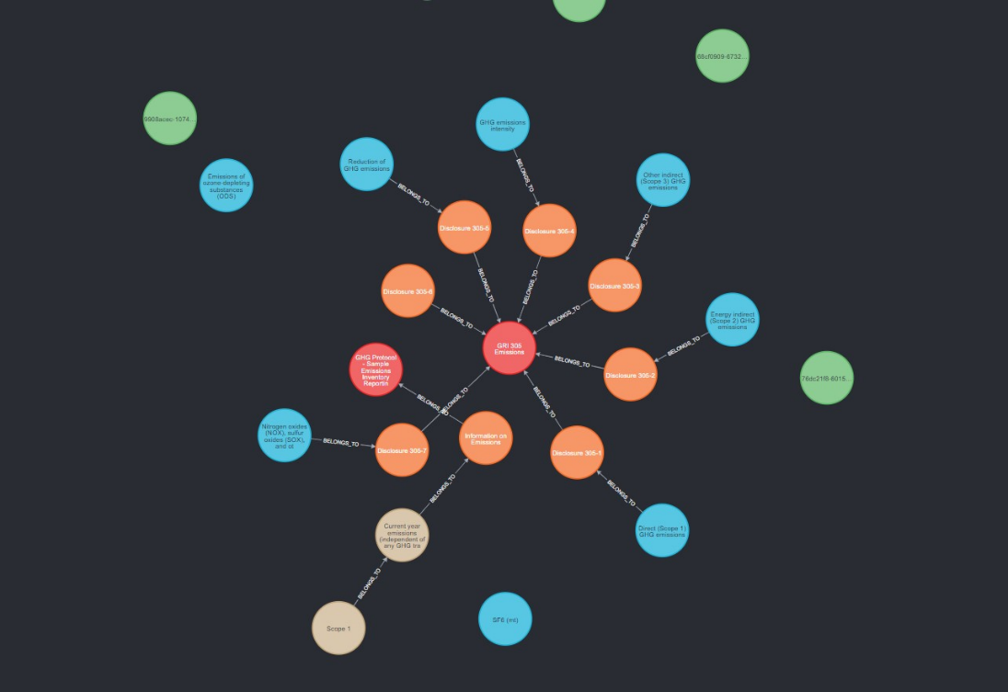

Figure 1 All Nodes

## 3.2 Steps to Configure

**3.2.1 To connect to a Neo4j instance hosted on AWS (Amazon Web Services), you can follow these steps:**

**1.** **Launch an EC2 Instance:**

- Log in to the AWS Management Console.

- Navigate to the EC2 service.

- Launch a new EC2 instance, ensuring that it meets the system requirements for running Neo4j.

- Configure security groups to allow incoming connections to the Neo4j ports (e.g., 7474 and 7687).

**2. Connect to the EC2 Instance:**

- Use SSH to connect to the EC2 instance using the public IP or DNS provided by AWS.

- Provide the necessary authentication credentials to access the instance.

**3. Install Neo4j on the EC2 Instance:**

- Update the system packages using the appropriate command for your operating system (e.g., `sudo apt update` for Ubuntu).

- Install Java Development Kit (JDK) if not already installed (`sudo apt install default-jdk` for Ubuntu).

- Download the Neo4j installation package using `wget` or `curl` (e.g., `wget https://neo4j.com/artifact.php?name=neo4j-community-<version>-unix.tar.gz`).

- Extract the downloaded package using `tar` (e.g., `tar -xf neo4j-community-<version>-unix.tar.gz`).

- Navigate to the extracted directory (`cd neo4j-community-<version>`).

**4. Configure Neo4j:**

- Open the Neo4j configuration file (`conf/neo4j.conf`) using a text editor (e.g., `sudo nano conf/neo4j.conf`).

- Modify the `dbms.default_listen_address` setting to allow remote connections if needed.

- Save the changes and exit the text editor.

**5. Start Neo4j:**

- Start the Neo4j service using the appropriate command for your operating system (e.g., `sudo bin/neo4j start`).

- Wait for Neo4j to start successfully.

**6. Access Neo4j from a Local Machine:**

- Open a web browser on your local machine.

- Enter the public IP or DNS of the EC2 instance followed by the Neo4j browser port (e.g., `http://<EC2-Instance-Public-IP>:7474`).

- If required, provide the Neo4j authentication credentials.

**7. Use Neo4j:**

- Once connected, you can use the Neo4j browser interface to execute queries, create nodes and relationships, and manage your graph database.

**Note:** Remember to properly secure your Neo4j instance by configuring firewall rules, enabling authentication, and following other security best practices.

.

**3.2.2 Solidatus JSON to Neo4j CSV Converter: GHG Protocol**

**1. Introduction**

This guide provides step-by-step instructions for importing JSON files exported from Solidatus and converting them into CSV files that can be directly imported into Neo4j to create a graph database of the GHG (Greenhouse Gas) Protocol. The GHG Protocol is an internationally recognized standard for accounting and managing greenhouse gas emissions.

This converter tool is designed to simplify the process of transforming Solidatus JSON files into a format compatible with Neo4j, allowing you to efficiently create a graph database to analyze and visualize GHG emissions data.

**2. Prerequisites**

Before starting the conversion process, ensure that you have the following prerequisites:

1. Solidatus JSON Files: Export the GHG Protocol data from Solidatus in JSON format.

2. Neo4j Database: Set up a Neo4j database to import the converted CSV files.

**3. Steps for Conversion**

Follow these steps to convert Solidatus JSON files into Neo4j-compatible CSV files:

**Step 1:** Install Required Dependencies

To perform the conversion, you need to install the following dependencies:

*1. Python:* Ensure that Python is installed on your system.

*2. Solidatus Library*: Install the Solidatus library using the following command:

```

pip install solidatus

```

3. *Pandas Library:* Install the Pandas library using the following command:

```

pip install pandas

```

**Step 2:** Prepare Solidatus JSON Files

Export the GHG Protocol data from Solidatus in JSON format. Make sure you have the necessary JSON files representing the entities and relationships of the GHG Protocol data.

**Step 3:** Run the Conversion Script

1. Download the "Solidatus JSON to Neo4j CSV Converter" script from the repository or copy the script code provided below:

```

import json

import pandas as pd

**Load Solidatus JSON data**

solidatus_json_file = 'path_to_solidatus_json_file.json'

with open(solidatus_json_file, 'r') as file:

solidatus_data = json.load(file)

**Convert entities to CSV**

entities_df = pd.DataFrame(solidatus_data['entities'])

entities_df.to_csv('entities.csv', index=False)

**Convert relationships to CSV**

relationships_df = pd.DataFrame(solidatus_data['relationships'])

relationships_df.to_csv('relationships.csv', index=False)

```

2. Modify the script to specify the correct file paths for the Solidatus JSON file and the desired output CSV file names.

3. Open a terminal or command prompt, navigate to the directory where the script is located, and execute the following command:

```

python solidatus_json_to_csv_converter.py

```

Make sure to replace `solidatus_json_to_csv_converter.py` with the actual filename if you renamed it.

4. The script will convert the Solidatus JSON files into CSV files named `entities.csv` and `relationships.csv`.

**Step 4:** Import CSV Files into Neo4j

1. Start your Neo4j database server and access the Neo4j browser interface.

2. In the Neo4j browser, execute the following Cypher queries to import the CSV files:

```

LOAD CSV WITH HEADERS FROM 'file:///entities.csv' AS row

CREATE (n:Entity)

SET n = row

```

```

LOAD CSV WITH HEADERS FROM 'file:///relationships.csv' AS row

MATCH (from:Entity {id: row.from_entity_id})

MATCH (to:Entity {id: row.to_entity_id})

CREATE (from)-[:RELATIONSHIP_TYPE]->(to)

```

Replace `Entity` and `RELATIONSHIP

_TYPE` with the appropriate node labels and relationship types based on your GHG Protocol data.

3. Once the queries are executed, the data from the CSV files will be imported into your Neo4j graph database.

**Conclusion**

By following this guide, you have successfully converted Solidatus JSON files into CSV files that are ready to be imported into Neo4j to create a graph database of the GHG Protocol. You can now leverage the power of Neo4j's graph database to analyse, query, and visualize your GHG emissions data efficiently.

# CHAPTER – 4

# 4. RESULTS

# Throughout the implementation of this project, numerous notable achievements have been attained, resulting in the enhancement of the data platform's functionalities and its seamless connection with Neo4j, a prominent graph database management system. The integration of Neo4j has proven to be highly effective in representing data through the use of nodes and relationships. This capability has facilitated the modeling of complex and interconnected datasets in many domains such as social networks, recommendation systems, and fraud detection. Additionally, our system currently features optimized data intake and synchronization processes, which guarantee the real-time or planned updating of data. This, in turn, enhances the precision and dependability of the data. The successful implementation of query optimization techniques for graph-based queries has resulted in enhanced query performance and the efficient retrieval of interlinked data. In addition, the interfaces that are supposed to be user-friendly have undergone careful and detailed planning, enabling users to easily create, execute, and visually represent intricate queries based on graphs. This, in turn, facilitates a more profound comprehension of the relationships within the data.

Moreover, the incorporation of machine learning algorithms has facilitated the utilization of predictive analytics on graph data, enabling users to reveal concealed patterns and extract practical insights from their datasets. The present research has not only augmented the capabilities of our data platform, but it has also made a valuable contribution to the field of data management by demonstrating the concrete advantages of incorporating graph databases into established data ecosystems.

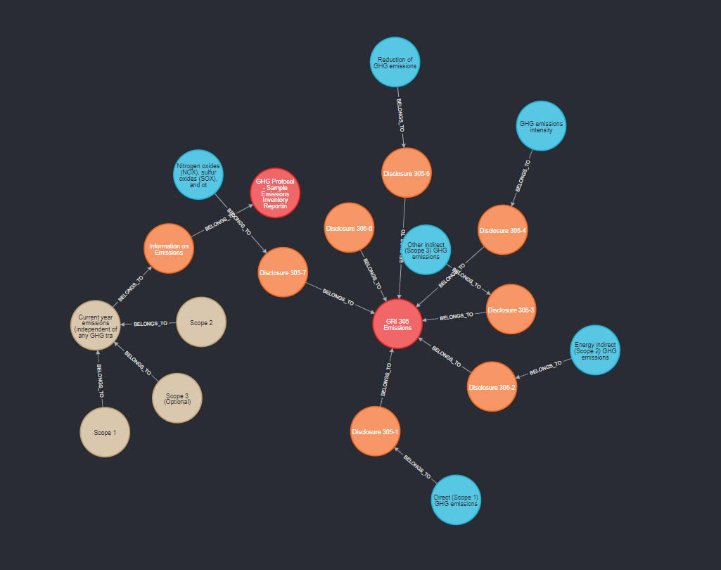

Figure 2 Relationship: belongs_to

# CHAPTER - 5

# 5. CONCLUSIONS

# This project signifies a notable advancement in enhancing the functions of a data platform by including graph database features, with a particular emphasis on Neo4j. Through a careful approach to resolving the defined need requirements, the project aims to accomplish a series of crucial objectives. The incorporation of Neo4j plays a fundamental role in enhancing data management by providing efficient storage and proficient handling of interconnected data. This, in turn, facilitates the successful modeling of complex relationships within the dataset. Additionally, the project aims to improve querying operations through the implementation of query optimization techniques and the development of user-friendly interfaces. This will enable users to effortlessly create and execute graph-based queries. This not only enhances the efficiency of data retrieval but also optimizes the data analysis process. Furthermore, the incorporation of machine learning techniques into Neo4j provides opportunities for predictive analytics on graph data. This enables users to discover hidden patterns and extract practical insights, thereby enhancing decision-making procedures. Additionally, the system provides a comprehensive range of tools for analyzing data and presenting it visually, facilitating the examination of intricate connections and enhancing the understandability and interpretability of the data. In addition, this system guarantees the ability to handle expanding datasets and integrates strong security measures to protect sensitive data stored in Neo4j. The project demonstrates a steadfast dedication to adhering to data privacy regulations, industry standards, and Neo4j best practices. This commitment is further enhanced by the provision of thorough documentation, which serves as a valuable resource for users and administrators, assisting them in effectively utilizing the system's functionalities. With comprehensive strategies in place for continuous maintenance, updates, and user assistance, the project commits to ensuring the enduring sustainability and dependability of the integrated data platform. Consequently, it aims to provide a solution that not only fulfills but also anticipates the evolving requirements of contemporary data management in an interconnected global context.

# CHAPTER - 6

# 6. REFERENCES

* <https://neo4j.com/docs/>
* <https://www.solidatus.com/resources/>